Exercises group 1

1. Match the correct thing with the correct word.

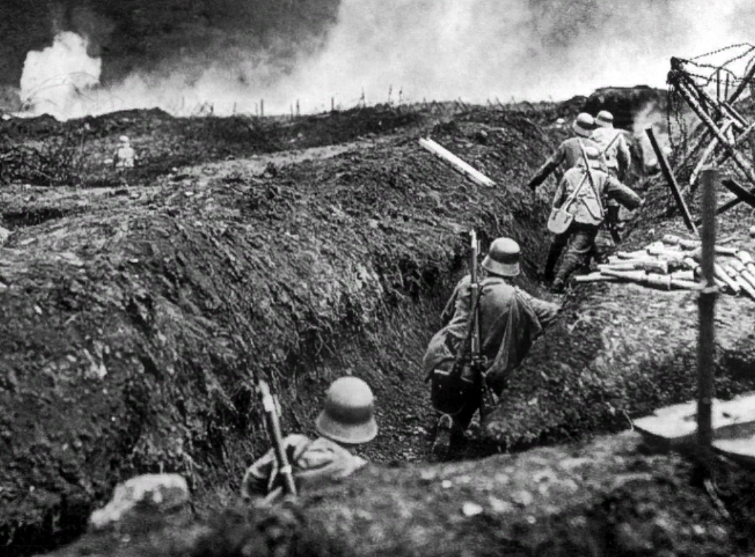
1____________ 3_____________
2______________

4____________ 6________________
5_____________
7__________________

Solutions: 1) helmet 2) trench 3) weapon 4) no man’s land 5) uniform – camouflage 6) barbed wire 7) grenade - shell

- Women and WWI: fill the gaps with amounts below.

In Britain during the war a)_______ women took up posts in government departments, b)_________ in private clerical positions and another quarter of a million in agriculture. This pales in comparison to the c)________ women who worked in the munitions industry. British Expeditionary force had around d)____ grenades a week at their disposal in 1914; by 1916 they would have e)______ bombs weekly.
In Britain during the war roughly f)________ women replaced men at their jobs. There were g)_________ women working in Britain in January 1918, munitionettes produced 80% of the weapons and shells used by British army and in British war hospitals there were h)_______ nurses.
In Russia the percentage of women in workforce jumped from a quarter to 43%, i)________ women joined the workforce in Austria and in France, where women were already a relatively large proportion of the workforce, female employment jumped 20%. Germany failed to introduce women in workplace.
Role of women in workplaces during WWI was the final push toward giving women the right to vote. In Britain at the end of the war j)__________ women were given the vote: these were women over the age of k)_______. They didn’t have eligibility too, but only 10 years later they could vote at the age of l)_____ years old like men. Germany, Russia and Poland give women suffrage in 1918, Austria in 1919, USA in 1920.

Solutions: a) 200,000 b) 500,000 c) 700,000 d) 40 e) 800,000 f) 2 million g) 5 million h) 80,000 i) 1 million j) 8,4 million k) 30 l) 21

